Human Development and Social Competence
All Africa Anthroposophic Training
12 - 19 December 2021
Dar es Salaam, Tanzania

Tanzania 2021 AAAT: Conference with a difference

Theme: THE STAGES OF INITIATION from chapter 2 of the book ‘How to know higher worlds” by Rudolf Steiner
Duration: 7 days
Date: 13 December 2021 to 18 December 2021
Venue: Vikindu Mkuranga, Tanzania
Conf Fees: US$ 105
Organization: website, facebook

…………………………………………………………………………………………………..

CONTENTS
1. Design of the conference
2. What is Initiation?
3. Making the conference a memorable learning experience
4. Milestones or past initiations of humanity
5. Birth (emergence) of Humanity
6. Individualization (the ‘I’ experience)
7. Intelligent man
8. Individual human evolution
9. Anniversary of mankind
10. Celebrating our individualization

…………………………………………………………………………………………………..

The fee for the training is as follows.

Invitation to the Tanzania All Africa Anthroposophical Training 2021

Accommodation & Food $245

Conference Fees $105

Transport from/to Airport $20 (on shared arrangement)

Grand Total $370

1. Design of the conference

The 3rd All Africa Anthroposophical Training (AAAT) conference will take place in Vikindu Tanzania during the second week of December 2021. The theme of the conference will be THE STAGES OF INITIATION from chapter 2 of the book ‘How to know higher worlds” by Rudolf Steiner.

As we plan the conference, we intend to create a big impact and lasting results, which we believe is the best way we can honor the founder of anthroposophy, our generous sponsors and the selfless speakers and facilitators. We have in mind a thought provoking, inspiring, and learner friendly experience.

This time the learning will be made even more interactive. We intend to engage participants from the design stage to the end of the conference and after. Experiences from the last conferences, especially the last one at Harare, have provided us with important lessons that will help us in optimizing our design. Our major assumption is that the majority of participants will be new to the subjects to be covered.

We have created the following guideposts to achieve this objective,
- Hands on, practical and interactive. Workshops will take place in demonstration fields as much as possible.
- A brief overview of subjects covered in previous conferences will be obtained from respective groups for sharing around, to provide context on which to build the next stage of the learning experience
- Facilitators will be requested to provide lesson outlines and interactive and reference materials for participants as early as possible, at least 2 months before the conference.
- The lesson outlines and reference materials will be made available online. Facilitators will be encouraged to open blogs to facilitate online dialogues especially these times of COVID 19.
- Participants will be expected to have prepared themselves well for the workshop, based on the lesson outlines, background and reference materials suggested by facilitators.
- Local groups will be required to organize a series of roundtables in their areas, preferably in different locations in order to involve and engage as many prospective candidates as possible virtually. These should include authorities, experts and students in the field. Experiences from these roundtables will inform the conference workshops. They will be made available to facilitators in advance of the conference.
- To enhance group learning, participants will be encouraged to share biographies and life experiences, to exchange testimonies from personal transformations, and to compare knowledge on the subject from different perspectives and traditions based on discoveries from their own investigation, observations and readings.
- Ideas, inquiries, and clarifications before the conference will be encouraged.
- We will try to make life during the conference as convenient as possible within the means available, in transportation, lodgings and foods. Much of the food will be vegetarian. Vegans and other special diets will be organized by advance booking
- Moderators will be available at all times from the planning stage to manage the interactions

2. What is Initiation?

The theme for the next All Africa Anthroposophical Training (AAAT) conference to be held in Tanzania in December 2021 will be “The stages of initiation” from chapter 2 of Rudolf Steiner’s book How to know higher worlds. The conference will cover the 3rd of 4 modules in a program on personal and social transformation

This essay is a simplified introduction to the main theme of the conference to those without a background on the subject of initiation.

Initiation is a part of history known as evolution, concerning the development and growth towards completion over time, of both humanity as a species, and after a certain stage of evolution, of the individual human being. While history is the search for understanding the past development and growth of creation since its conception, initiation is the process of bringing this process to its ultimate completion. It could also be related to the evolution of the planet and the universe as a whole.

People always wonder why bother with unusual subjects like initiation when our daily existence itself is already challenging enough? Many, reason that such subjects are a luxury not meant for ordinary citizens struggling to earn a modest existence, but for those who can afford the time and resources. And yet that which seems to challenge these people in their lives is in fact an inherent urge towards completing their own development. In evolution, the human being is an ongoing project, still a “work in progress”. The world has seen nothing of the perfect human being yet.

This process towards perfection, towards completion of things (given the cumbersome name eschatology) is actually what gives meaning and incentive to human existence. But unless you know where you come from, you will not know where you are going, which gives no sense to life. That is why the history of the world, its beginning and its successive seeding is the basis of all creation mythologies. Every society has an established tradition about the nature of creation and their place in it; where their people came from and where they are heading to, that gives them hope and the inspiration to encounter the challenges of life with joy. A future without meaning can be horrifying, as is so common in our modern society that lacks such “metaphors”.

Even in our age, science has conceived for us its infinitely expanding spatial creation within time. From it we learn that the universe and all living things evolve from simple to complex systems, from a seedling to full maturity. As of now according to science, creation is still in the early stages of its making, still shaping the perfect image. And so is mankind within it.

According to these “metaphors”, the future holds great promise for mankind, the assurance of absolute freedom, of eternal peace, bliss and joy. Everyone would love to exercise their endowments as complete human beings, the infinite capacities within themselves that unfold through the slow process evolution. Even in our time, we find people who are behind in development, for instance those whose minds are undeveloped, are pitifully disadvantaged, while those who are ahead, the creatives (the few whose intuition is awakening) command a great advantage.

Left to nature, perfection will take many eons to attain. Through initiation however, these capacities and perfect state of human nature can be awakened and fully developed, bestowing great advantage to the individual.

“Initiation bestows upon us knowledge and abilities we would otherwise acquire in a different way and form only in the distant future, after many incarnations”. Rudolf Steiner

3. Making the conference a memorable learning experience

Tanzania, the venue for the next AAAT also happens to be home to the most important archeological sites of earliest human ancestry in the world. Casting initiation within the broader context of history will give it an easier perspective from our time, simplify presentation and help our understanding of this important cosmic law.

In an effort to present the subject of initiation in a more realist way and make it even easier for everyone to grasp, the conference will include actual visits to these historical sites. We believe visits to these remarkable demonstration sites of our human origins and early development will be a very good historical opportunity that will lend great momentum and tremendously enhance our learning experience. The conference will be very highly celebrated by this event. This will be arranged separately before the conference dates for those interested.

Nearest site is Bagamoyo where is an historical site with archeological sites located 100km from from the conference venue. The original settlement, Kaole, was founded c. 800 CE, and grew into an important trading town by the 13th century. The Kaole Ruins contain the remnants of two mosques and 30 tombs, dated back to the 13th century. Around the 17th century, the settlement 2–3 miles north of Kaole began growing. This area grew in prosperity, acquiring the name Bagamoyo by the 18th century as an important stop in the caravan trade (the name means "Baga=Drop & Moyo=Soul, therefore, "Drop Your Soul.

Upon request, we will put together a program to include this incredible experience so basic to our lives and so relevant to the theme of the AAAT conference this time.

4. Milestones or past initiations of humanity

Phase of development and growth
Very simply, initiation is a stage or milestone that marks a particular phase of development in the growth of an individual. It could also apply to mankind as a species, as well as to the planet and the universe. Hidden in every individual are faculties higher than those presently accessible, which give considerable advantage to the individual concerned. These faculties unfold over time through evolution. They can also be made accessible through personal development like education. The unfoldment of these higher faculties by the individual is the subject of this study.

In our study of initiation, we will first examine stages or milestones on the long path of development and growth of mankind as a species in nature, from its birth many millions of years ago (mya). This preliminary study will help to build in us the foundation or context of our main study at the conference, which will be chapter 2 of Steiner’s book “How to see higher worlds”. The subject concerns the awakening and development of faculties higher than those in the possession of the average thinking human being of our present time.

This preliminary study will be conducted on line in preparation for the actual subject to be discussed at the conference.

5. Birth (emergence) of mankind

In the evolution of mankind as a species, the first initiation could be its birth, the beginning point when mankind separated from the animal kingdom and started walking upright 4 million years ago (mya). We can picture, that creature must have been more an animal than a human being.

According to anthropologists, what could be the first human being, the Australopithecus afarensis as they call it, left human-like footprints on volcanic ash at Laetoli in northern Tanzania 4.0 Mya, providing strong evidence of full-time bipedalism, or walking on two legs.

Its successor,the Paranthropus boisei, with more apelike features, a sagittal crest (back swept scull), but a rounded cranial brain and a robust jaw, known as “Nutcracker man” was there until 1.75 million years ago and was thought to use simple tools.

6. Individualization (the ‘I’ experience)

The next important milestone or initiation could be recognized again when individual human beings started to develop self-awareness and become independent persons apart from the herd. Until then humanity could be counted as one entity, one inseparable system made up of individual persons. The stage of individualization enabled individual human beings to start to develop self-identity, to become self-aware, to see him or herself as separate and apart from his or her environment.

Science identifies this stages with what they call Homo habilis that appeared 2.8 mya at the Olduvai Gorge, a steep-sided ravine in the Great Rift Valley nearby. The creature, with a brain half the size of modern man, appears—the first, or one of the first, hominins to master stone tool technology.
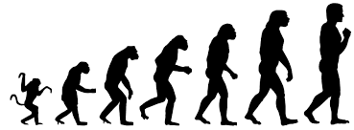
Another, the Homo erectus also lived there 1.9 Mya. Upright man, the man made hand axes and occupied the site until Homo sapiens appeared 195,000 years ago. H. erectus is also the first known species to develop control of fire, by about 1.5 Mya.

7. Intelligent man

The stage when senses had developed enough for the individual to form emotions or memorable feelings is also an important milestone. The human being I associate with the emergence of this stage 0.3mya is called by science Homo sapiens
Homo sapiens (Homo sapiens idaltu) in Ethiopia, Awash River (near present-day Herto village) practiced mortuary rituals, an important emotional expression.

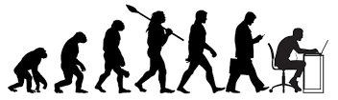
The Homo sapiens sapiens is another important milestone when the individual begins to think and to make decisions independently. We are definitely entering this stage at this time.

Initiations or milestones on the path of evolution of the human kingdom
Birth | individualization | feeling | thinking | Intuition and beyond
Australopithecus afarensis | Homo habilis 2.8 mya | Homo sapiens | Homo sapiens sapiens
Paranthropus boisei | Homo erectus
The individual as an integral part of the herd, inseparable from it | The individual as an independent entity, a system by itself | The beginning of ntelligence

Please note that since these discoveries in Tanzania, even older fossils have been discovered in Create and Romania as well as in Asia, pushing the date of human origins beyond 7mya.

8. Individual human evolution

The individual’s conception, birth, weaning, adolescence, youth and manhood in the life of a human being could also be regarded as milestones of individual growth or initiation.

Milestones of individual growth
Stage | conception | birth | Falling of milk teeth | adolescence | youth
Institution | The womb | Parental care | kindergarten | Primary school | High school
faculty | body | instinct | willing | feeling | thinking

Independent think is the highest stage of growth recognize in our time, attained by the individual human being. But we are told it is not the end of human development and growth. Intuition for example, which is often confused with instinct, is the imminent stage of development higher than thinking, characterizing the rare genius and brilliant creatives we would all wish to become.

These stages, milestones or initiations are usually characterized by great changes or leaps, in the behavior; and in the initial stages of human growth, in the physical features of the entity as well. In terms of creativity for example, an independent thinker has greater creativity than a purely emotional individual. Likewise the intuitive is infinitely more creative than an average thinker.

These stages of human development and growth arrive naturally to individuals. Educational institutions nowadays have taken over from nature the development of thinking in individuals. Education is recognized as the advantage in developed economies today.
There are so far no public institutions established for awakening and developing the intuition, and stages higher than that.

For those familiar with waldorf education they will find much relevance with the 3fold nature of the human being of willing, feeling and think here.

After the long evolution of mankind, individual human beings now are beginning to assume responsibility for their own development and growth. Actually development of the intuition and stages higher than that have been there, but until very recently, it was the domain of esoteric institutions, also called occult or esoteric institutions. These are very private institutions, the privilege of very special distinctive individuals.

At the beginning of the 20th century, Rudolf Steiner came up with his spiritual science to make public what was then esoteric, occult or secret knowledge. He called his organization Anthroposophy, which means knowledge of the Self, for the development of those faculties higher than thinking, that bring the advantages of higher development and growth.

9. Anniversary of mankind

Every tradition sets aside holy days to celebrate important events associated with the history of its people. The most common holy day is the birth day. On Rosh Hashanah, Jews celebrate the birth of creation. Christmas is the birthday of Christ the savior of mankind. December 21, 2012 was celebrated worldwide as the end of the long count Mayan calendar, marking the beginning of another 25,000-year cycle of development of the world, also explored in the book Hamlet’s mill.

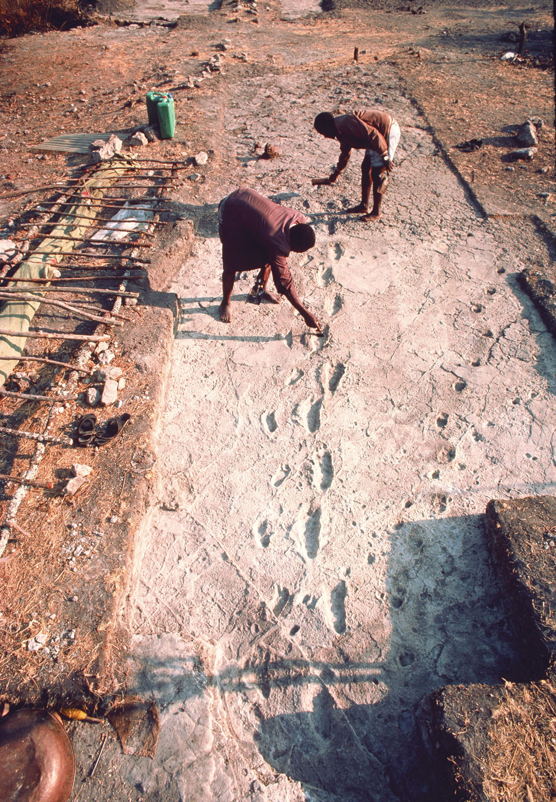
As part of the conference, we will use the occasion to honor the birth of mankind and to remind ourselves of the important milestones on the long path of evolution humanity as a species has trekked. According to science, mankind took the first steps to separate itself from the animal kingdom 3.5mya. The occasion took place at Laetoli. The celebration will include a pilgrimage to our birth place.

Here at Laetoli in northern Tanzania, we will have the opportunity to stand on a huge bolder and witness the crossroads where 3.5mya mankind is seen drifting away from the animal herd. Clear footsteps of animals are seen heading one way while those of an adult human being and a child heading their separate way, not by chance but deliberately as seen here in the photograph. This tantalizing event is interpreted by science as the birth of mankind.

10. Celebrating our individualization

We will also use the opportunity to present about the Olduvai Gorge in the great eastern rift valley nearby, to honor our individualization, the time mankind started to be weaned of our complete dependence on mother nature.

As introduction, Olduvai, 48km from Laetoli, we witness various stone implements devised by our prehistoric ancestors to sustain and protect themselves. This was the time when the human being of that time started to see him or herself as an individual apart from his or her environment, which they could adapt creatively to sustain themselves.
That is the time mankind started to assume senses and enter consciously the school of life. This stage will be attested by crude stone implements conserved at the Olduvai museum.

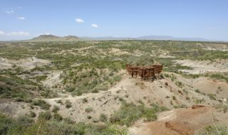
Olduvai Gorge is a rich archaeological site in Tanzania where evidence of the first humans has been found.

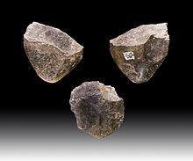  "A sharp rock", an Oldowan pebble tool, the most basic of human stone tools. | 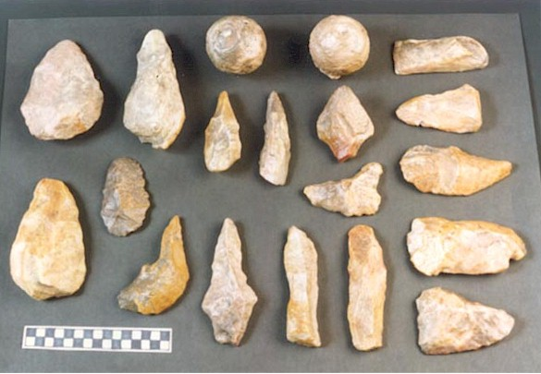

Olduvai Gorge facts
The Olduvai Gorge is a steep-sided ravine in the Great Rift Valley that stretches through East Africa. It is in the eastern Serengeti Plains in northern Tanzania.
The Gorge is about 48 km (30 mi) long. It is 45 km from the Laetoli archaeological site. The gorge is a highly important prehistoric site for the study of human evolution. It was once a lake, and got covered by layers of volcanic ash.
This site was occupied by Homo habilis about 1.9 million years ago, Paranthropus boisei 1.8 million years ago, and Homo erectus 1.2 million years ago. Homo sapiens occupied the site 17,000 years ago.
The name is a misspelling of Oldupai Gorge, which was adopted as the official name in 2005. Oldupai is the Maasai word for the wild sisal plant Sansevieria ehrenbergii, which grows in the gorge.

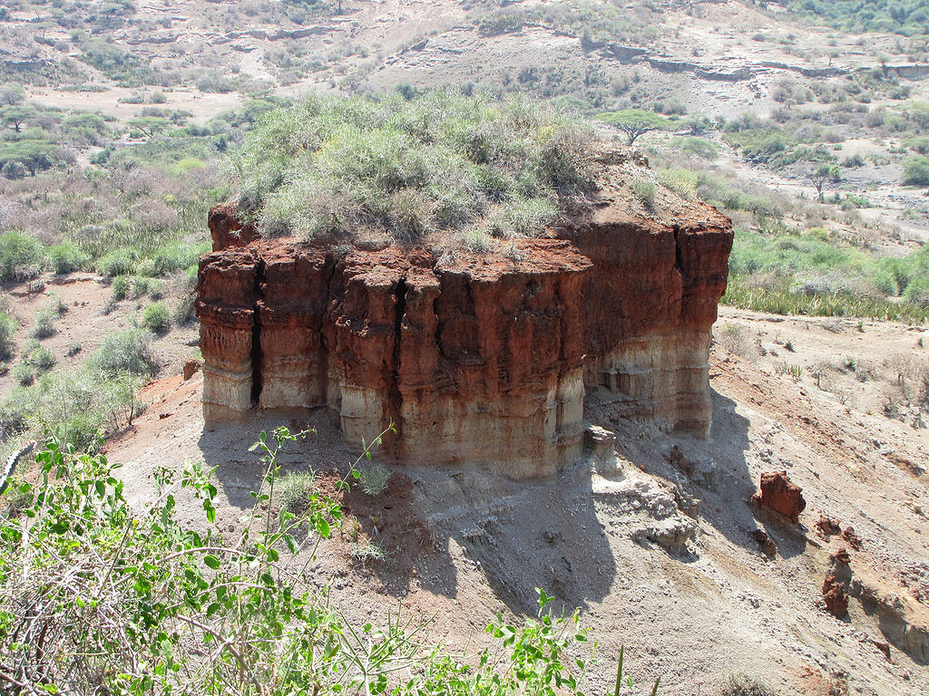
Weathered monolith where one can clearly trace the strata of succeeding changes in climate over millions of years

…..…………………We welcome you to beautiful Tanzania………………………..

END

